

Practices for Secure Software Report

Table of Contents
Document Revision History 3
Client 3
Instructions 3
Developer 4
1. Algorithm Cipher 4
2. Certificate Generation 4
3. Deploy Cipher 4
4. Secure Communications 4
5. Secondary Testing 4
6. Functional Testing 4
7. Summary 4
8. Industry Standard Best Practices 4

Document Revision History

Version | Date | Author | Comments
1.0 | 10/18/2026 | Torryona Lindsey | Initial submission-Practices for Secure Softeare Report

Client



Instructions

Submit this completed practices for secure software report. Replace the bracketed text with the relevant information. You must document your process for writing secure communications and refactoring code that complies with software security testing protocols.

- Respond to the steps outlined below and include your findings.
- Respond using your own words. You may also choose to include images or supporting materials. If you include them, make certain to insert them in all the relevant locations in the document.
- Refer to the Project Two Guidelines and Rubric for more detailed instructions about each section of the template.

Developer
[Insert your name here.]

Algorithm Cipher
Artemis Financial handles sensitive financial information, so it needs strong security to protect customer data and prevent unauthorized access. I recommend using AES-256 for symmetric encryption and modern TLS for secure communication between the application and its users. SHA-256 should also be used to verify data integrity through checksums. Each algorithm has a different purpose, and using them together provides multiple layers of protection.
AES is a symmetric encryption algorithm, which means the same secret key is used to encrypt and decrypt information. AES supports 128-bit, 192-bit, and 256-bit keys. AES-256 provides a strong level of protection for sensitive financial information when it is implemented correctly, and the encryption keys are securely managed. Random numbers are important in security because unpredictable values can be used to generate secure keys, initialization vectors, and other cryptographic values. These values should come from a secure random number generator.
Asymmetric cryptography uses a public key and a private key instead of one shared secret key. RSA and elliptic-curve cryptography are examples of asymmetric approaches used in secure communications. A public key can be shared, while the private key must remain protected. TLS uses cryptographic mechanisms to authenticate servers and establish secure connections, and modern TLS configurations can use strong symmetric encryption to protect data in transit.
Encryption technology has changed over time as computers have become more powerful and older algorithms have been found to have weaknesses. Older standards, such as DES, are no longer appropriate for protecting sensitive information because their security is insufficient by modern standards. AES is a widely used modern encryption standard. SHA-256, part of the SHA-2 family, produces a 256-bit hash value. Hashing is different from encryption because it is designed to produce a one-way digest rather than recover the original information. For Artemis Financial, using modern TLS, strong encryption, secure key management, and SHA-256 checksums can help protect financial information and detect changes to data.

Certificate Generation
Insert a screenshot below of the CER file.

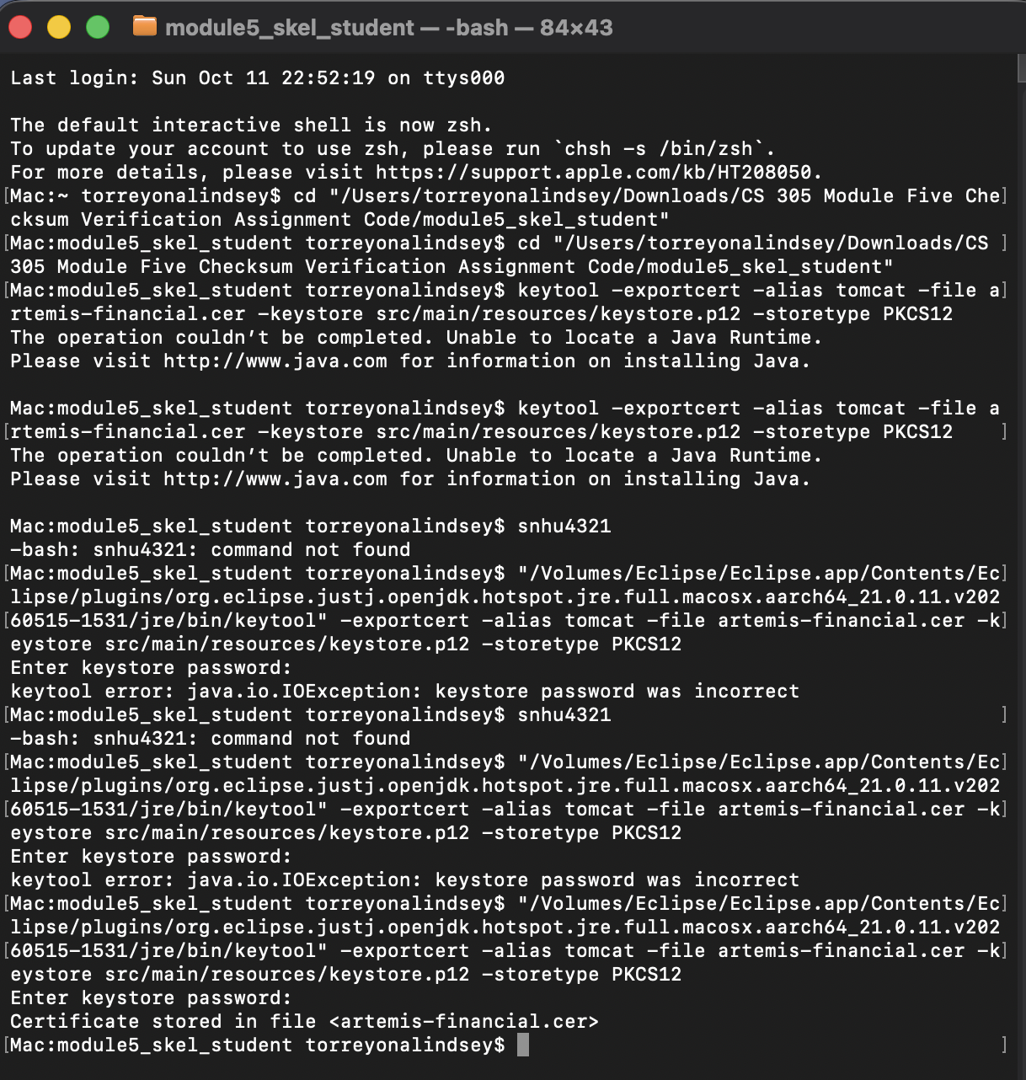

Deploy Cipher
Insert a screenshot below of the checksum verification.

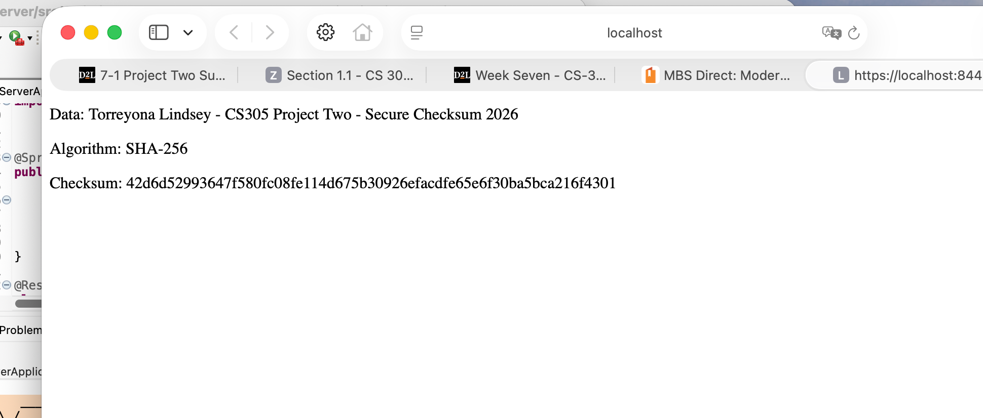
I implemented the SHA-256 hashing algorithm to generate a checksum for a unique data string. The application displays the original data and its checksum, allowing the hash value to be compared with a newly generated value to help identify whether the data has changed. SHA-256 supports data integrity verification because even a small change in the input should produce a different hash.

Secure Communications
Insert a screenshot below of the web browser that shows a secure webpage.

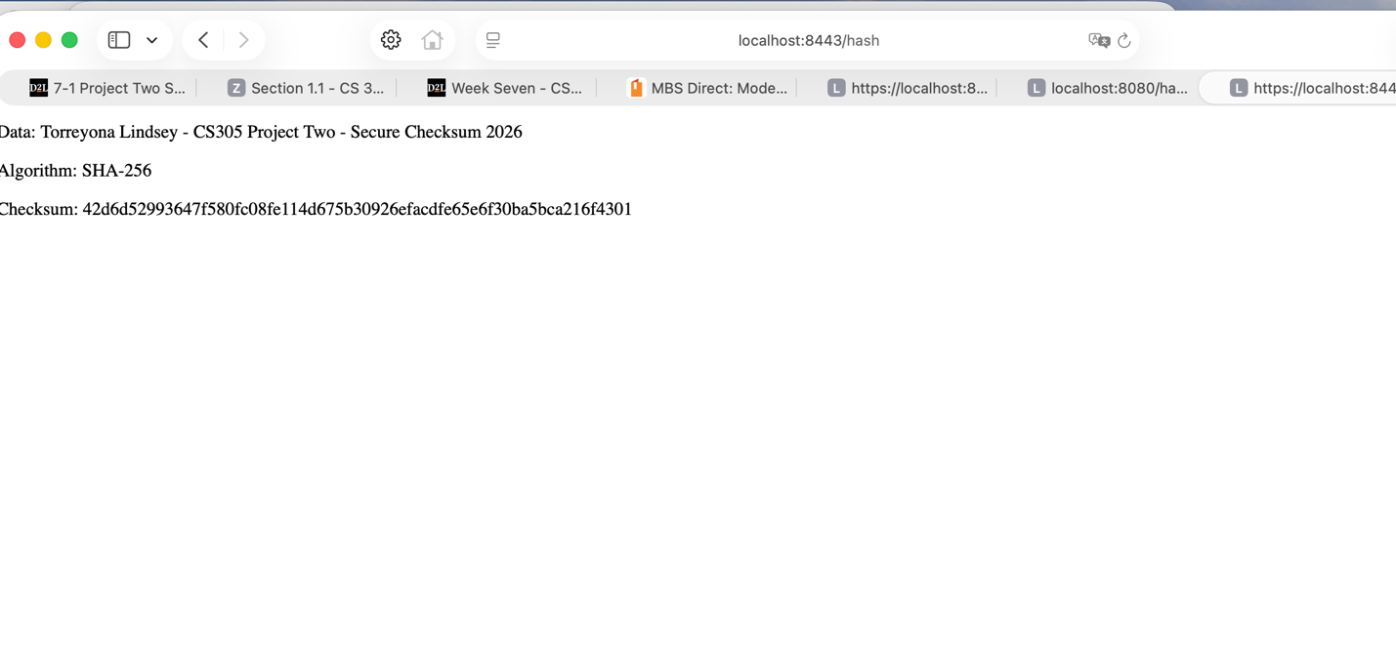
I updated the application.properties file to enable HTTPS on port 8443 and configured the application to use its keystore and certificate. I tested the application by opening https://localhost:8443/hash in Safari. The page successfully displayed my data string and SHA-256 checksum. Because the certificate is self-signed, the browser may not automatically trust it, but the application successfully starts and serves the page over HTTPS.

Secondary Testing
Insert screenshots below of the refactored code executed without errors and the dependency-check report.

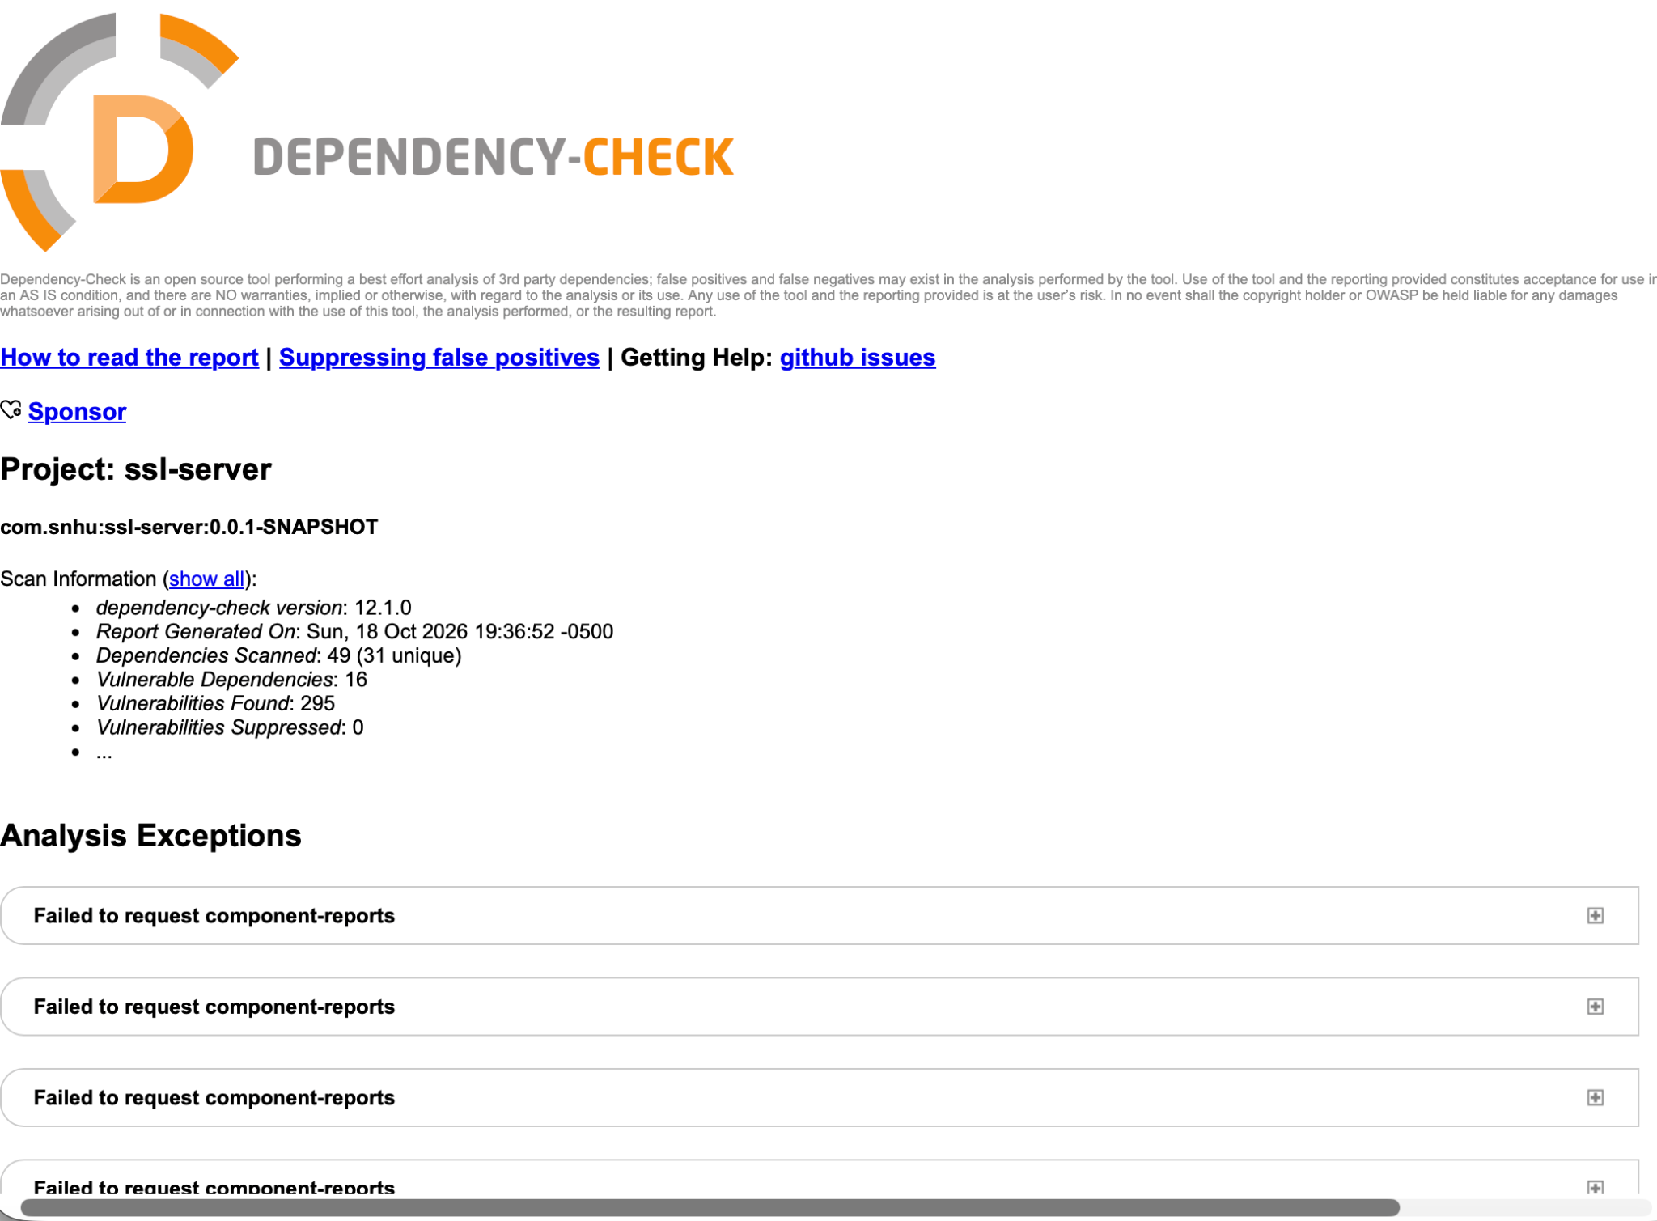

Functional Testing
Insert a screenshot below of the refactored code executed without errors.

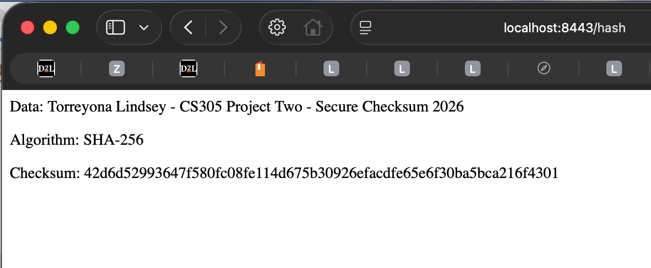

Summary
During this project, I improved the security of the application by implementing SHA-256 hashing and configuring HTTPS to protect communication between the browser and the server. I also generated a checksum using a unique data string and verified that the application returned the expected result. Testing confirmed that the application started successfully and that the /hash endpoint worked over HTTPS.
I used OWASP Dependency-Check to review the project's third-party libraries for known vulnerabilities. The scan completed successfully and identified 14 vulnerable dependencies with 254 reported vulnerabilities. Some of the affected libraries included Spring Boot, Spring Framework, Tomcat, and Jackson Databind. These results show that successful testing does not automatically mean an application is free of security risks. The findings should be reviewed, and vulnerable dependencies should be updated or otherwise addressed after checking compatibility and potential impact.
Overall, this project showed me that secure software requires more than writing code that works. Using hashing, encrypted communication, functional testing, and dependency scanning helps identify risks and protect data. Regular testing and maintenance are also necessary to keep an application secure.
vulnerabilities are discovered.

Industry Standard Best Practices
To maintain the security of this application, I would continue using current security standards and testing the software regularly. HTTPS should be configured with a trusted certificate and modern TLS settings to protect information while it is being transmitted. SHA-256 can help verify data integrity, but hashing alone does not encrypt information or protect an entire communication session.
Another important practice is keeping software dependencies updated. The Dependency-Check report identified vulnerable libraries, so those findings should be reviewed and addressed by updating affected packages to supported versions when possible. After updates, the application should be tested again to make sure it still works correctly and that the changes do not introduce new problems.
Passwords and other sensitive configuration values should also be stored securely rather than exposed in source code or public repositories. Developers should follow secure coding practices, review their code for weaknesses, and run security scans as part of regular maintenance. These steps help reduce security risks, protect sensitive information, and support the business by improving reliability and customer confidence.

